For the Dexian CodeAIThon, we’ve provided a client facing use case below. If your team wishes, you may come up with your own use case, however, that use case must meet the following criteria.
The case must either
- Directly impact and accelerate a specific aspect of the software development lifecycle,
OR
- Be directly related to one of IT Solutions sales pillars (See the definition and documentation on A.I.D.E.)
In addition, the use case must both:
- Use and add to the Dexian AI Framework and
- Have S.M.A.R.T. goals (to ensure a chance of success during the timeline of the CodeAThon.
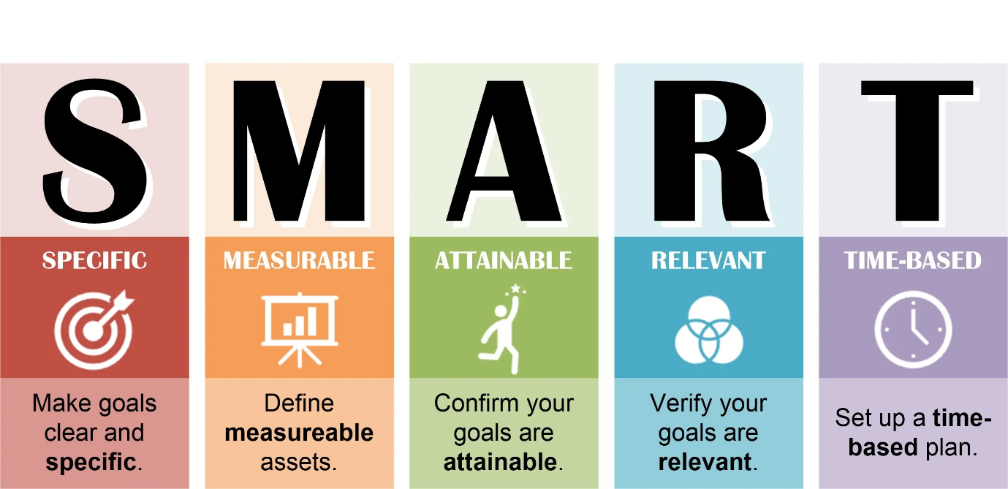

Standard Use Case
This project aims to automate the extraction and benchmarking of key operational and financial metrics from SEC filings and supplementary materials for selected companies, focusing on segment-level data when available. The system will handle diverse formats including HTML, PDF, and PowerPoint, combining traditional parsing with advanced language and image models to manage non-standardized and scattered data. Outputs will be a standardized, analysis-ready tabular dataset with source references and confidence flags, updated quarterly for 10–15 companies, ensuring reliable, repeatable, and reviewable data extraction suitable for benchmarking and trend analysis.

Project Specification
- Objective: Automate extraction and benchmarking of key operational and financial metrics from SEC filings and supplementary materials (HTML, PDF, PowerPoint) for a set of target companies, focusing on segment-level data where available.
- Inputs: Publicly available SEC reports (10-K, 10-Q), supplementary tables (HTML/PDF), and ad hoc materials (PowerPoint, images) from multiple companies.
- Metrics to extract include but are not limited to:
  - Specification Update: Metrics to Extract from SEC Filings (Per Basin Basis)
  - Production Data
    - Oil mbbl/d
    - NGL mbbl/d
    - Gas mbbl/d
    - BOE mboe/d
    - Oil mmbls
    - NGL mmbls
    - Gas bcf
    - BOE MMBOE
  - Activity / Well Information
    - Drilling Rigs by Basin (Segment, Asset)
    - Gross Wells Drilled by Basin (Segment, Asset)
    - Gross Wells Completed by Basin (Segment, Asset)
    - Gross Wells TIL-ed by Basin (Segment, Asset)
    - Net Wells TIL-ed by Basin (Segment, Asset)
    - Total Lateral Length of Wells Drilled
    - Total Lateral Length of Wells Completed
    - Total Lateral Length of Wells TIL-ed
    - Working Interest (WI)
    - Revenue
    - Oil Revenue
    - NGL Revenue
    - Gas Revenue
    - Total Revenue
    - Total Revenue $/BOE
    - Realized Price - Oil
    - Realized Price - NGL
    - Realized Price - Gas
    - Realized Price - BOE
- Challenges: Non-standardized table formats, inconsistent labeling, data scattered across multiple files and formats, and occasional data in images or charts.
- Frequency: Run extraction and benchmarking quarterly for a set of 10–15 companies.
- Output: Tabular dataset with all extracted metrics, segment breakdowns, source references, and confidence/outlier flags for review.
Definition of Done
- The system reliably extracts all specified metrics from the latest quarterly filings and supplementary materials for all target companies, regardless of format variations.
- Segment-level data is captured where disclosed; fallback to higher-level aggregates if not available.
- All extracted data includes references to the original source (document and location within document).
- Outliers and low-confidence results are flagged for manual review, with confidence scores or rationale provided.
- The process is repeatable and can be executed quarterly with minimal manual intervention, requiring only updates for new company lists or material format changes.
- Output is delivered in a standardized, analysis-ready tabular format suitable for benchmarking and trend analysis.
- List of companies to extract includes (Ticker Symbol and CIK Code)
  - "1": ("FANG", "0001539838"),
  - "2": ("PR", "0001658566"),
  - "3": ("DVN", "001090012"),
  - "4": ("OVV", "0001792580"),
  - "5": ("CTRA", "0000858470"),
  - "6": ("EOG", "0000821189"),
  - "7": ("SM", "0000893538"),
  - "8": ("VTLE", "0001528129"),
  - "9": ("MTDR", "0001520006"),
  - "10": ("OXY", "0000797468"),
  - "11": ("XOM", "0000034088"),

